DELHI TECHNOLOGICAL UNIVERSITY

(FORMERLY DELHI COLLEGE OF ENGINEERING)

SHAHBAD DAULATPUR ,BAWANA ROAD,DELHI-110042

DEPARTMENT OF COMPUTER SCIENCE AND ENGINEERING



INFORMATION AND NETWORK SECURITY

LAB FILE CS 305 IPM LAB

SUBMITTED TO: SUBMITTED BY:

DR. ASHISH KUMAR KRRISH KUMAR

ASSISTANT PROFESSOR BTECH: 3rd YEAR

DEPT. OF CSE 23/EE/320

**INDEX**

|  |  |  |  |
| --- | --- | --- | --- |
| **S.No.** | **Experiment** | **Date** | **Sign.** |
| 1. | Write a program to encrypt and decrypt a message using a caesar cipher |  |  |
| 2. | Write a program to encrypt and decrypt a message using Playfair Cipher. |  |  |
| 3. | Write a Program to implement Hill Cipher algorithm that encrypts pairs of letters and also implement Decryption  Algorithm. |  |  |
| 4. | Implement the RSA public-key encryption and decryption process, including key generation. |  |  |
| 5 | Write a Program to demonstrate how two parties can establish a shared secret key over an insecure communication channel using **Diﬃe-Hellman key exchange algorithm.** |  |  |
| 6. | Write a program to implement the multiplicative inverse of a number under mod. |  |  |
| 7. | Write a program that demonstrates the critical properties of the SHA-512 hash function. |  |  |
| 8. | Write a program to Implementation of Digital Signature Standard (DSS) using RSA based digital signature scheme. |  |  |
| 9. | Installation and usage of Wireshark or tcpdump to capture and analyze network traffic (UDP/TCP/HTTP sessions). |  |  |
| 10. | Experimenting with OpenSSL to set up a secure web server-browser communication channel (SSL/TLS). |  |  |

# EXPERIMENT NO. – 1

**Aim** Write a program to encrypt and decrypt a message using a caesar cipher

**Theory**

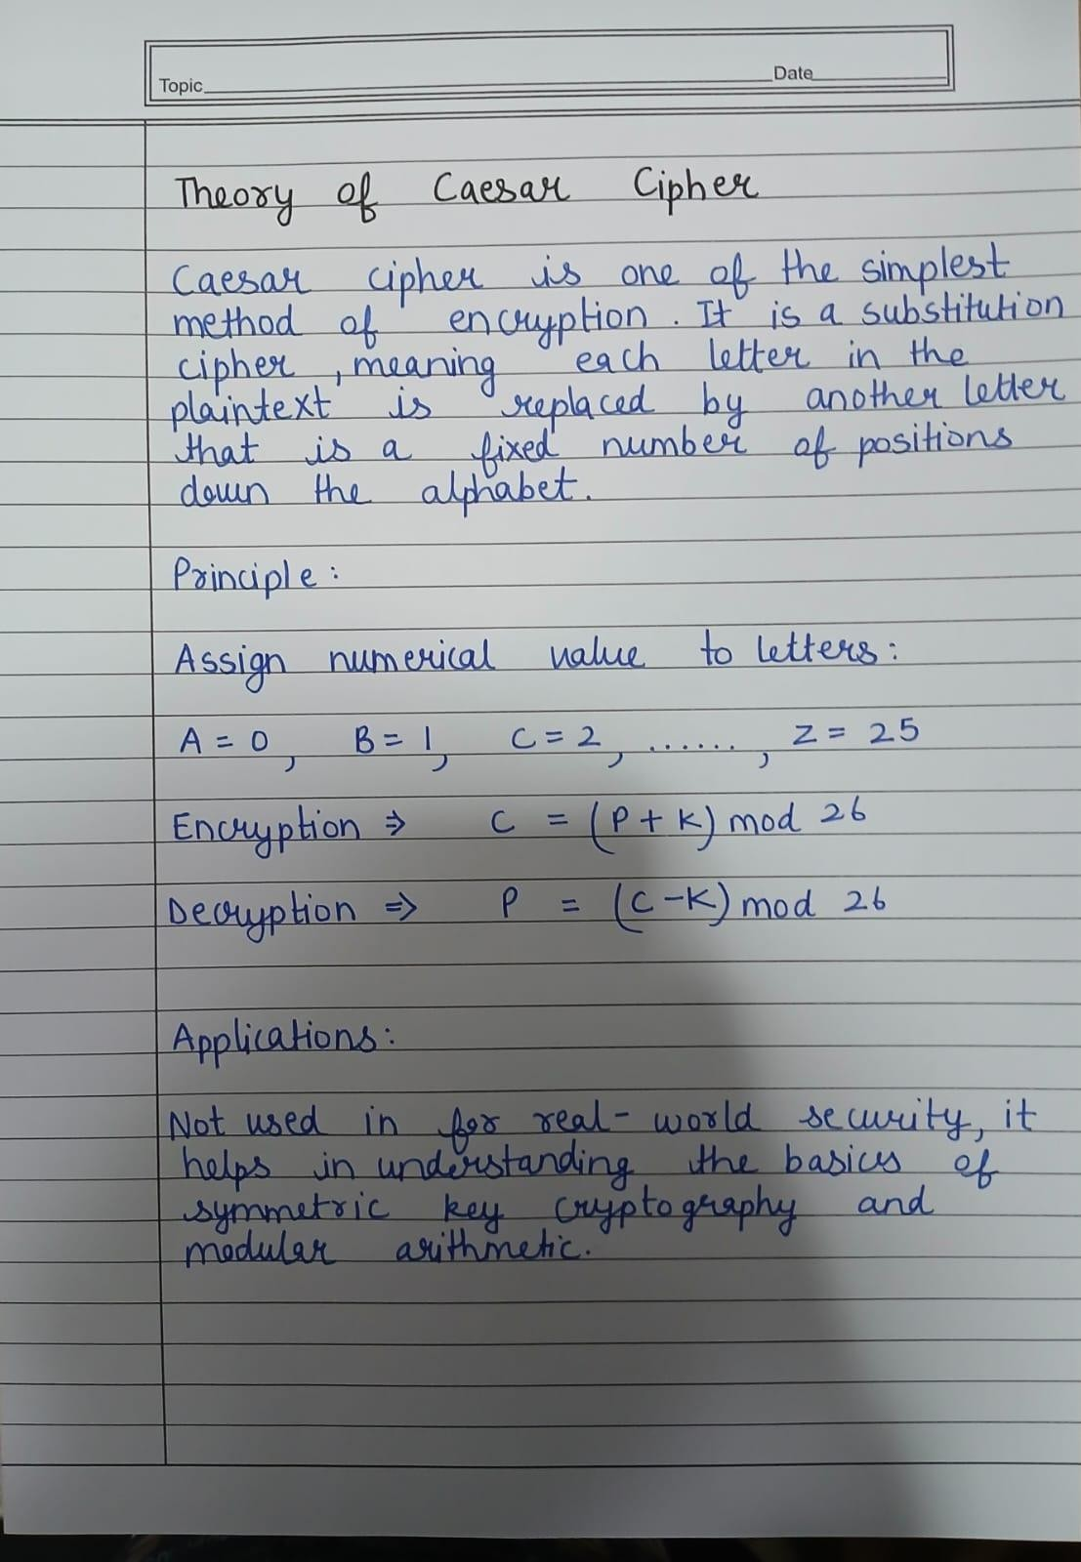

**Numerical Problem**

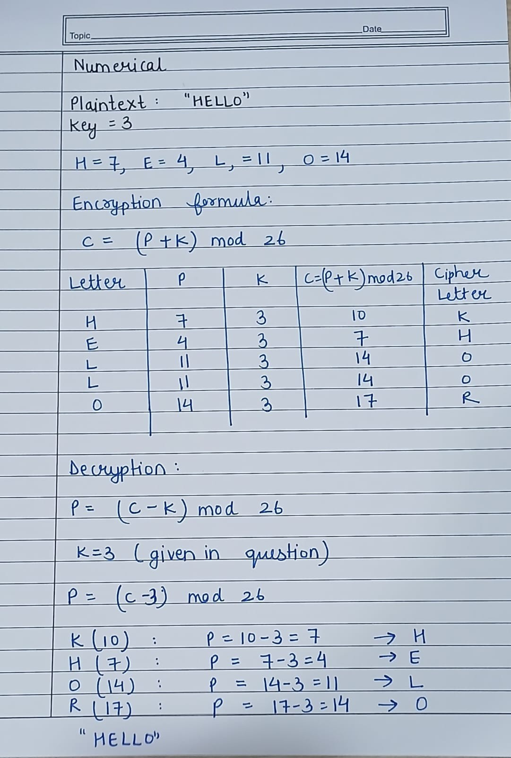

**Code**

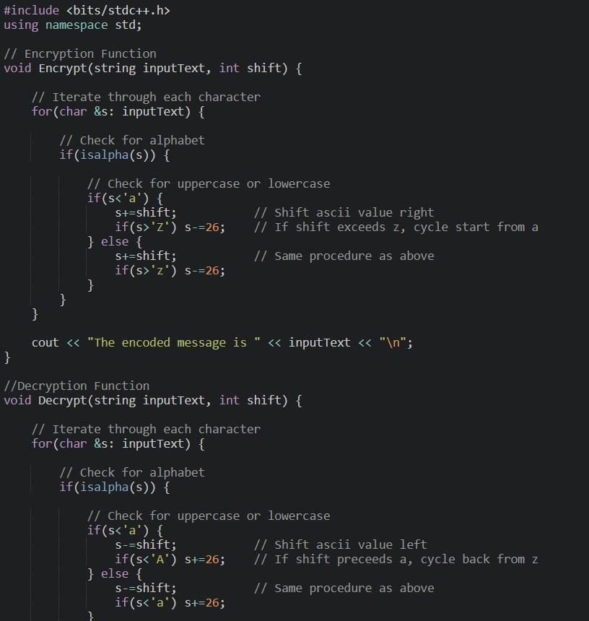

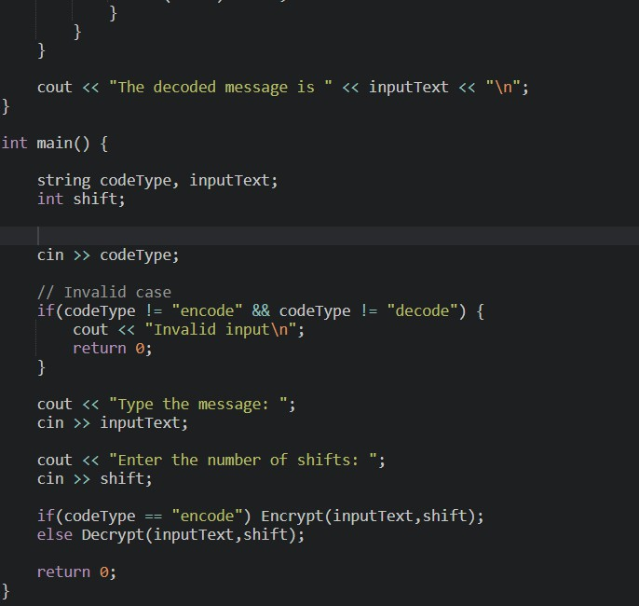

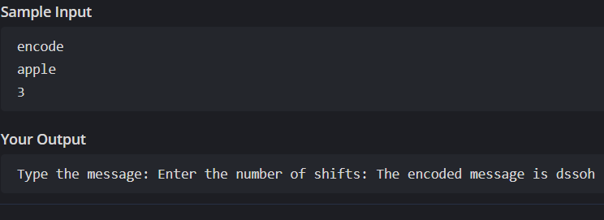**Output encrypt**

**Decrypt:**

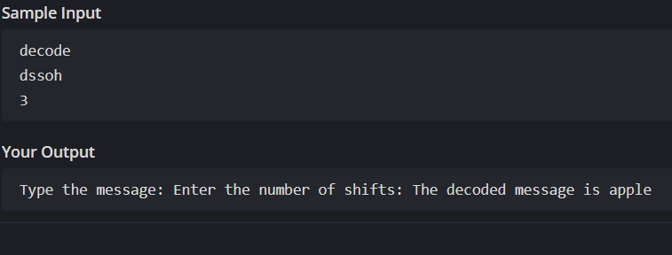

**Learning Outcome**

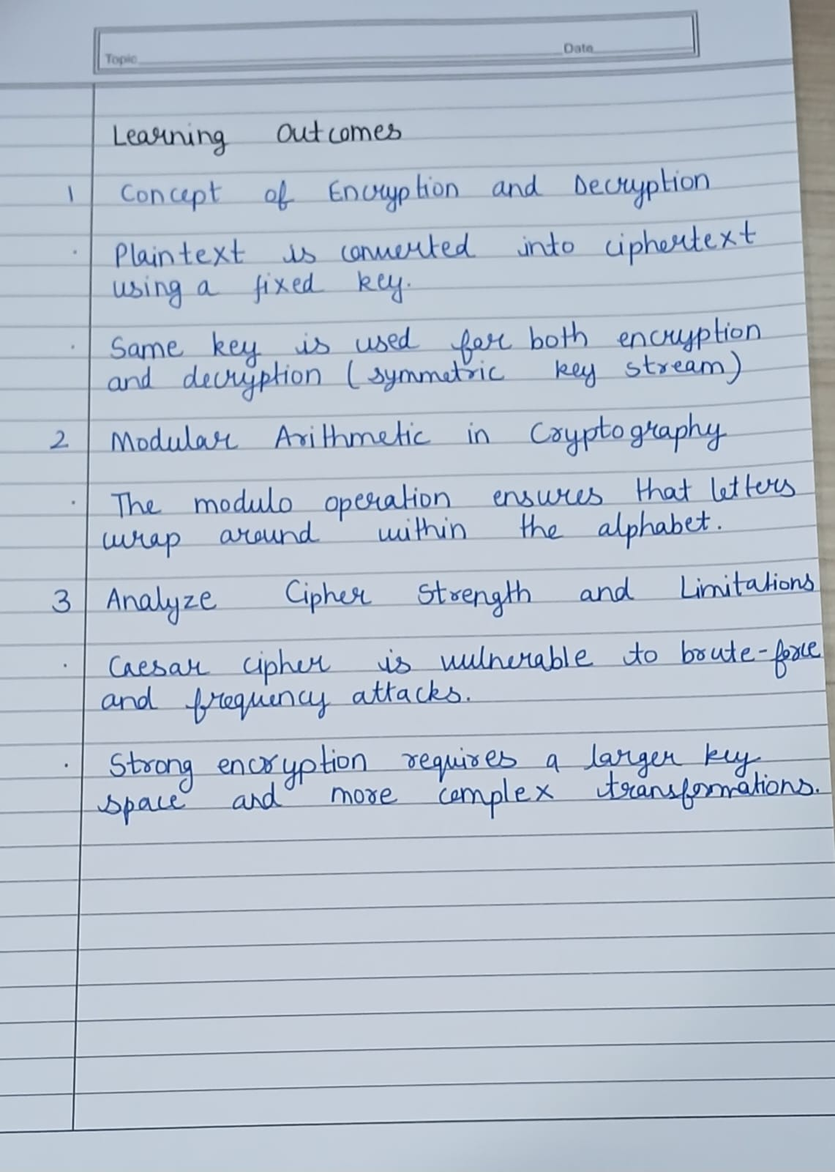

# EXPERIMENT NO. – 2

**Aim** Write a program to encrypt and decrypt a message using Playfair Cipher.

**Theory**

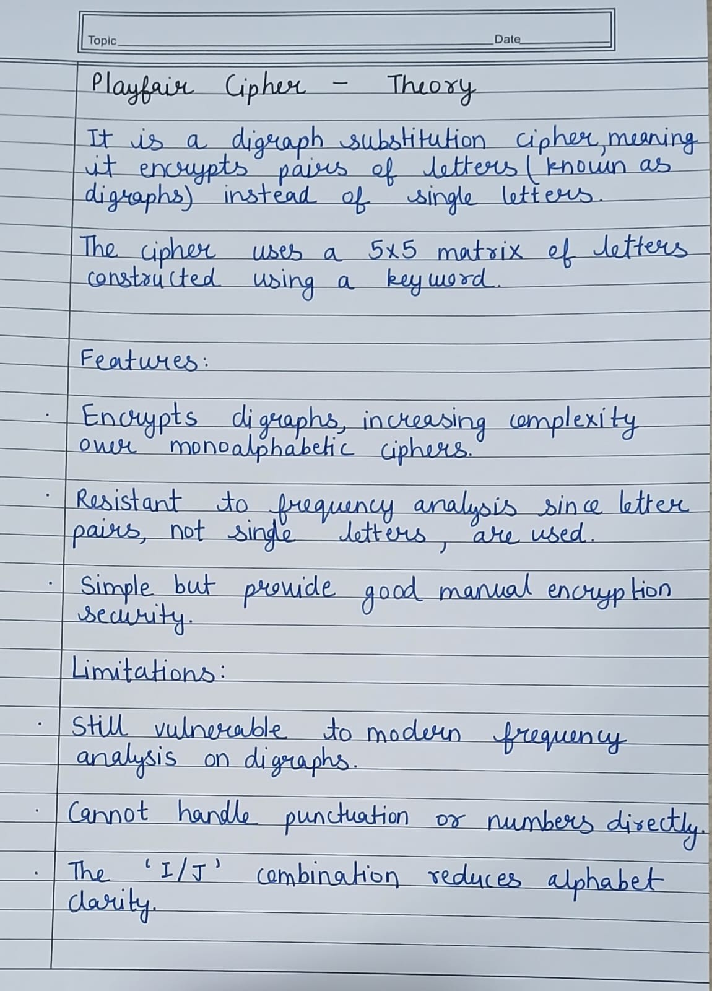

**Numerical Problem**

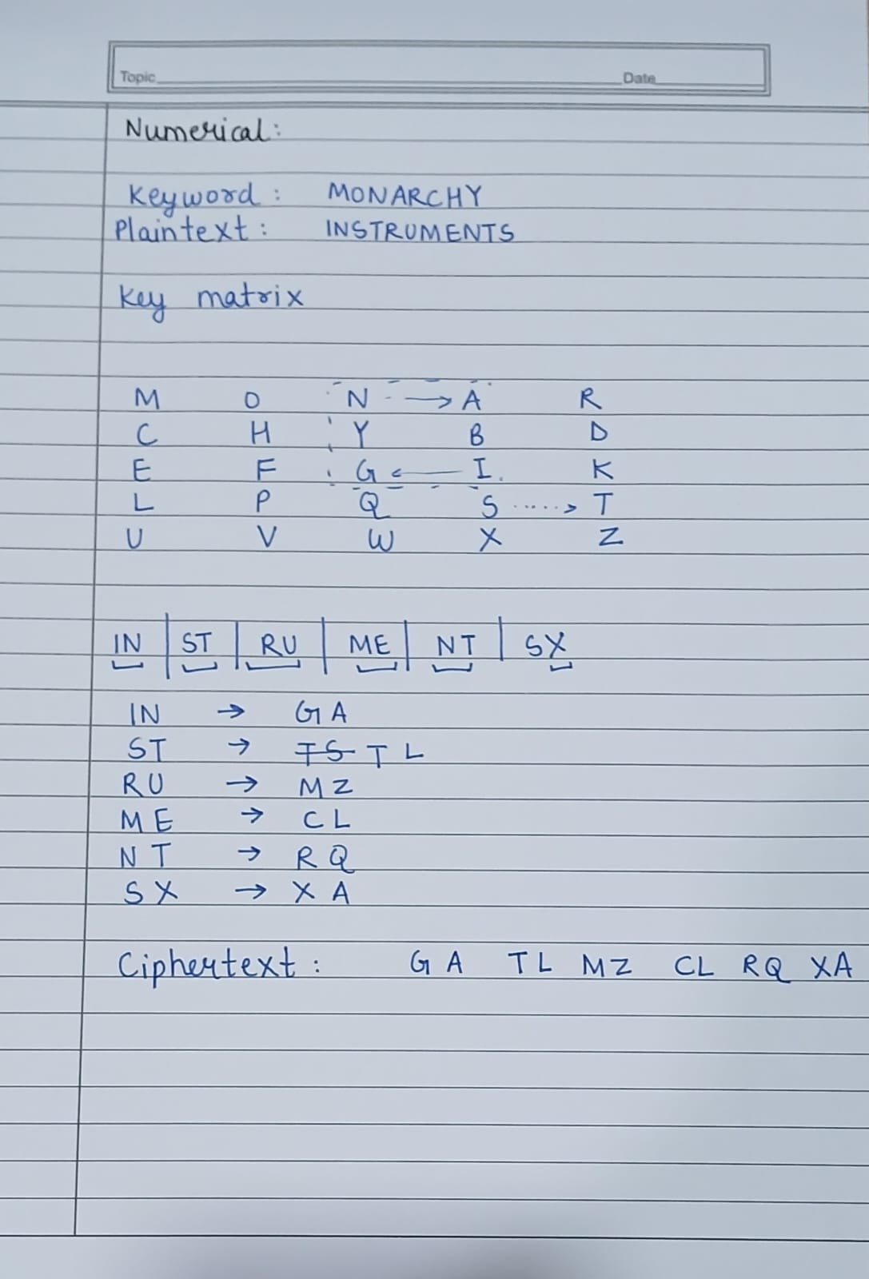

**Code**

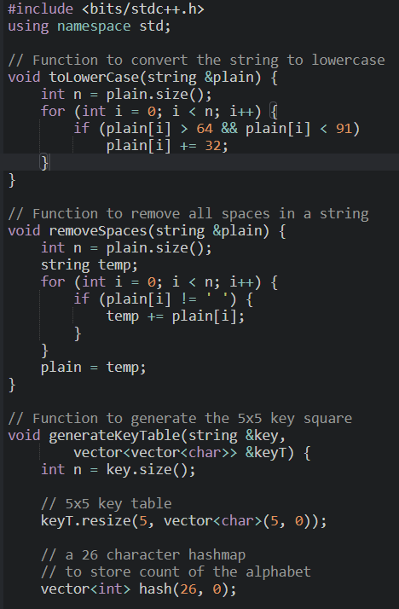

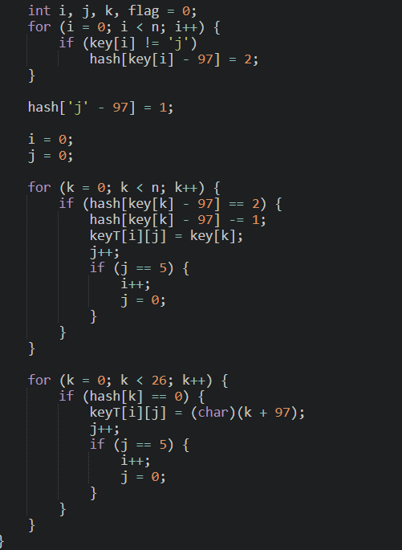

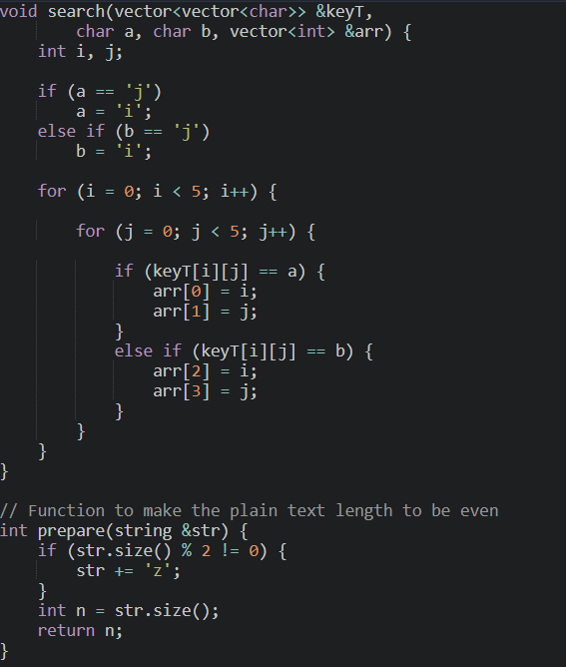

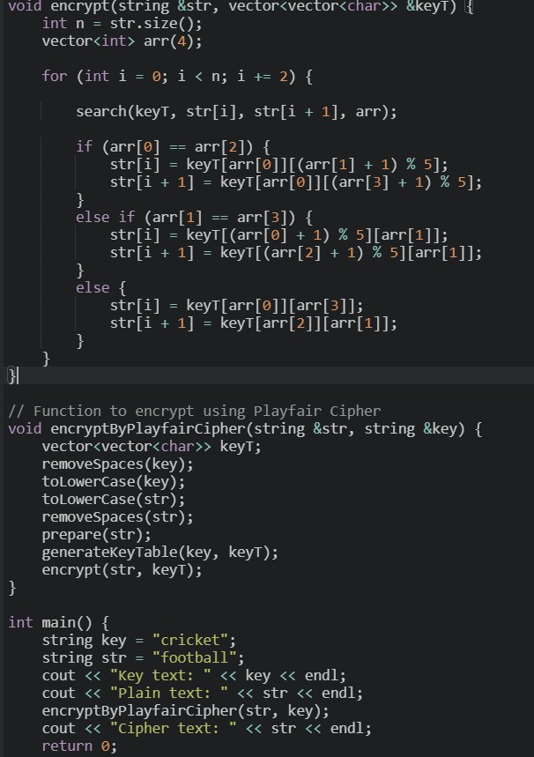

**Output**

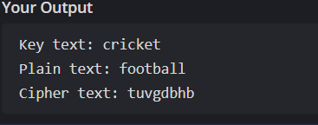

**Learning Outcome**

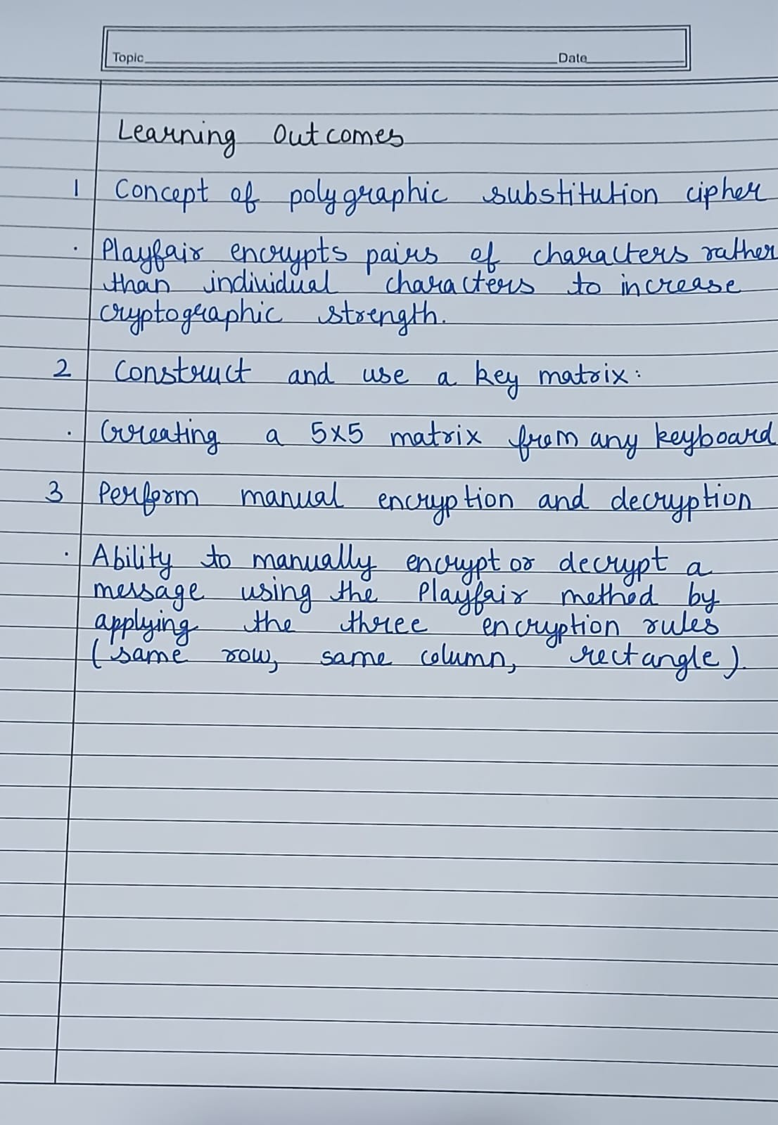

# EXPERIMENT NO. – 3

**Aim** Write a Program to implement Hill Cipher algorithm that encrypts pairs of letters and also implement Decryption Algorithm

**Theory**

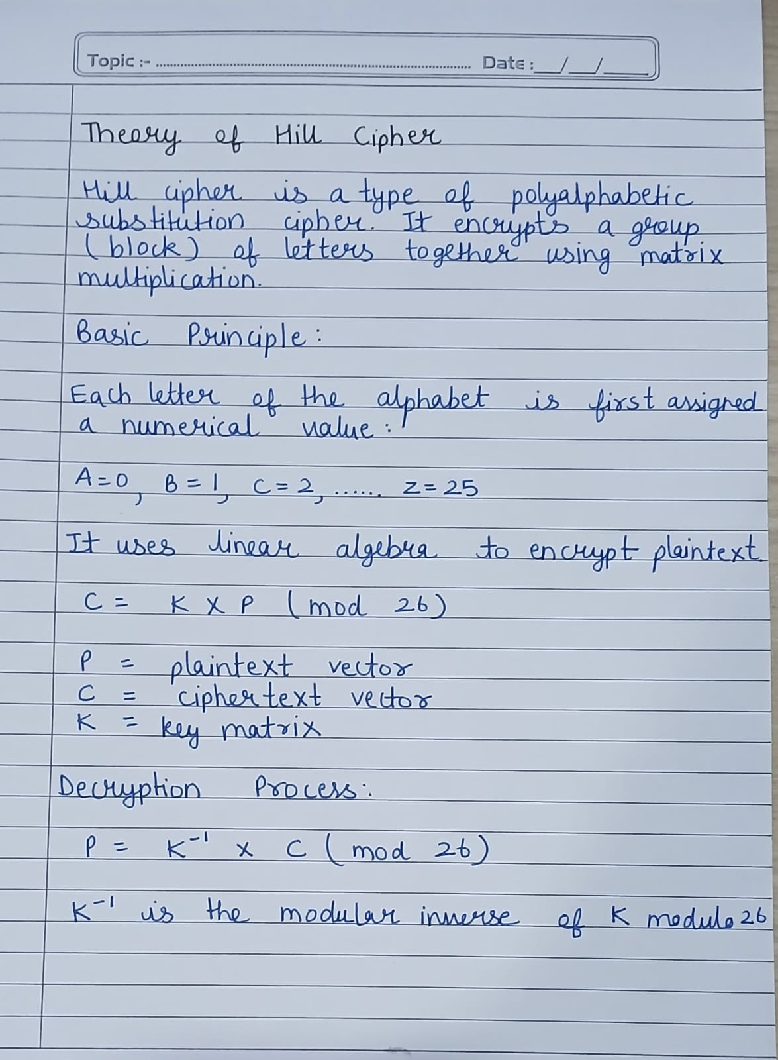

**Numeical Problem**

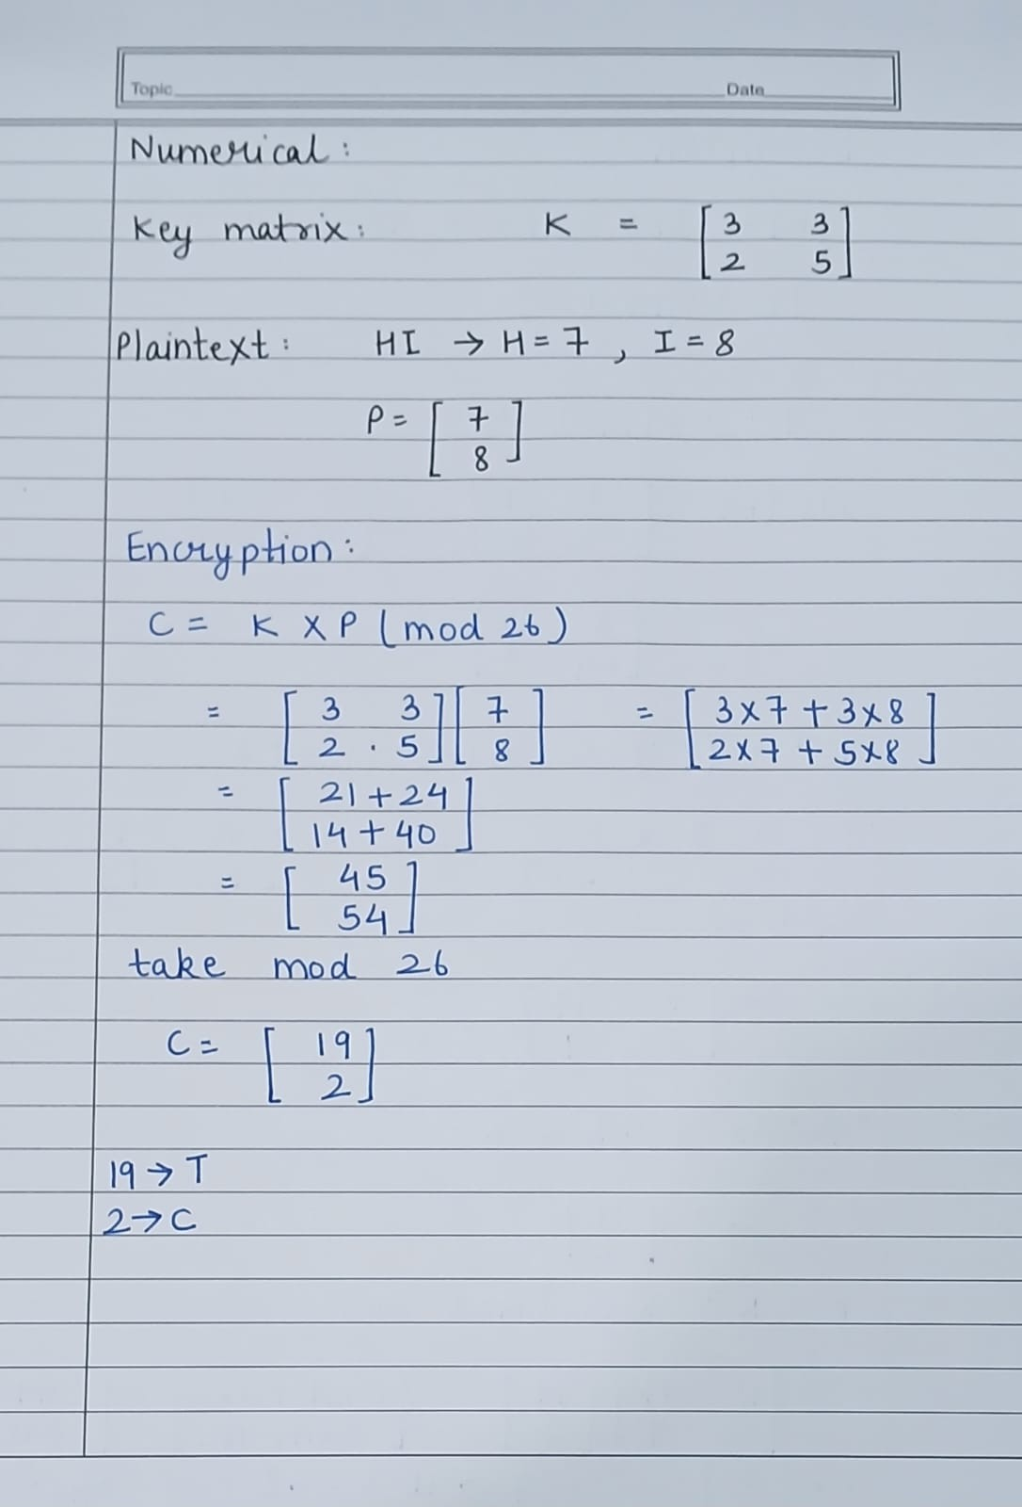

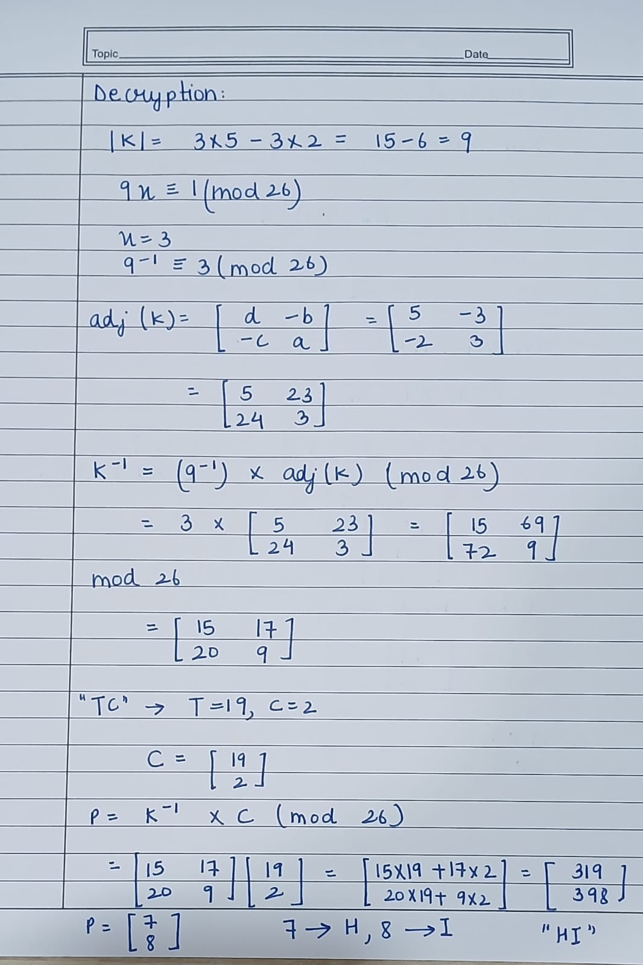

**Code**

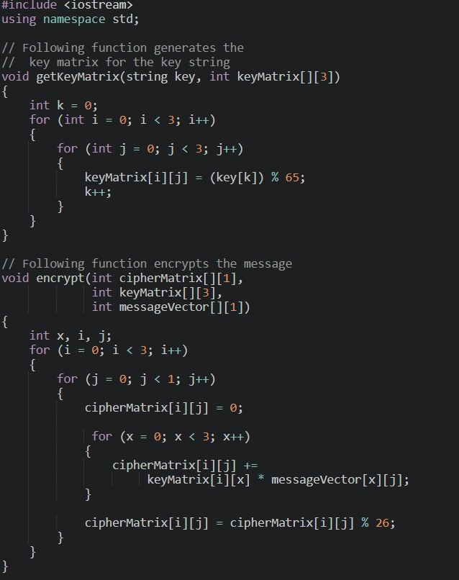

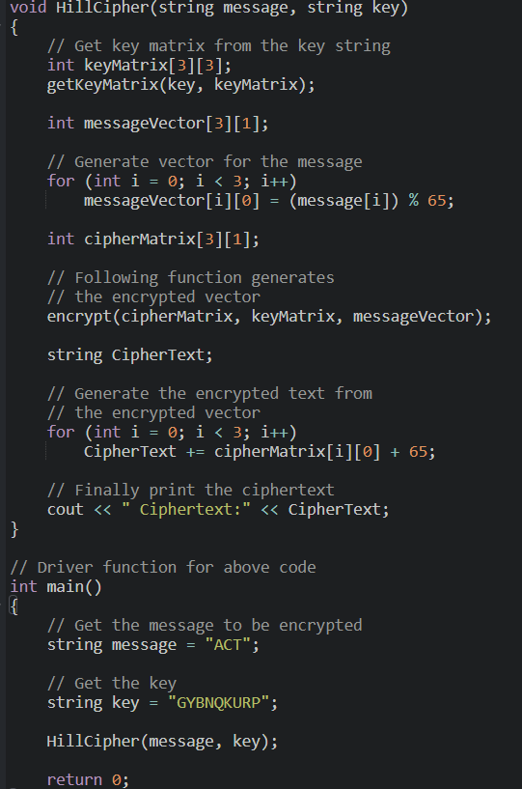

**Output**

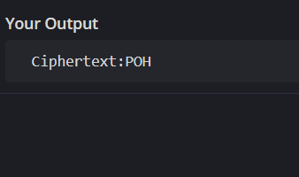

**Learning Outcome**

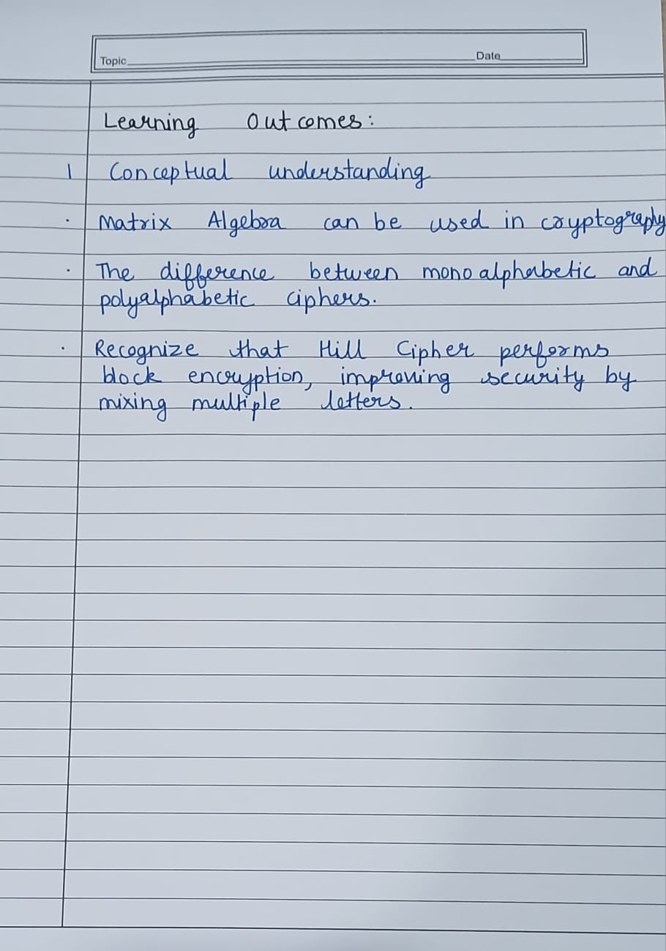

# EXPERIMENT NO. – 4

**Aim** Implement the RSA public-key encryption and decryption process, including key generation

**Theory**

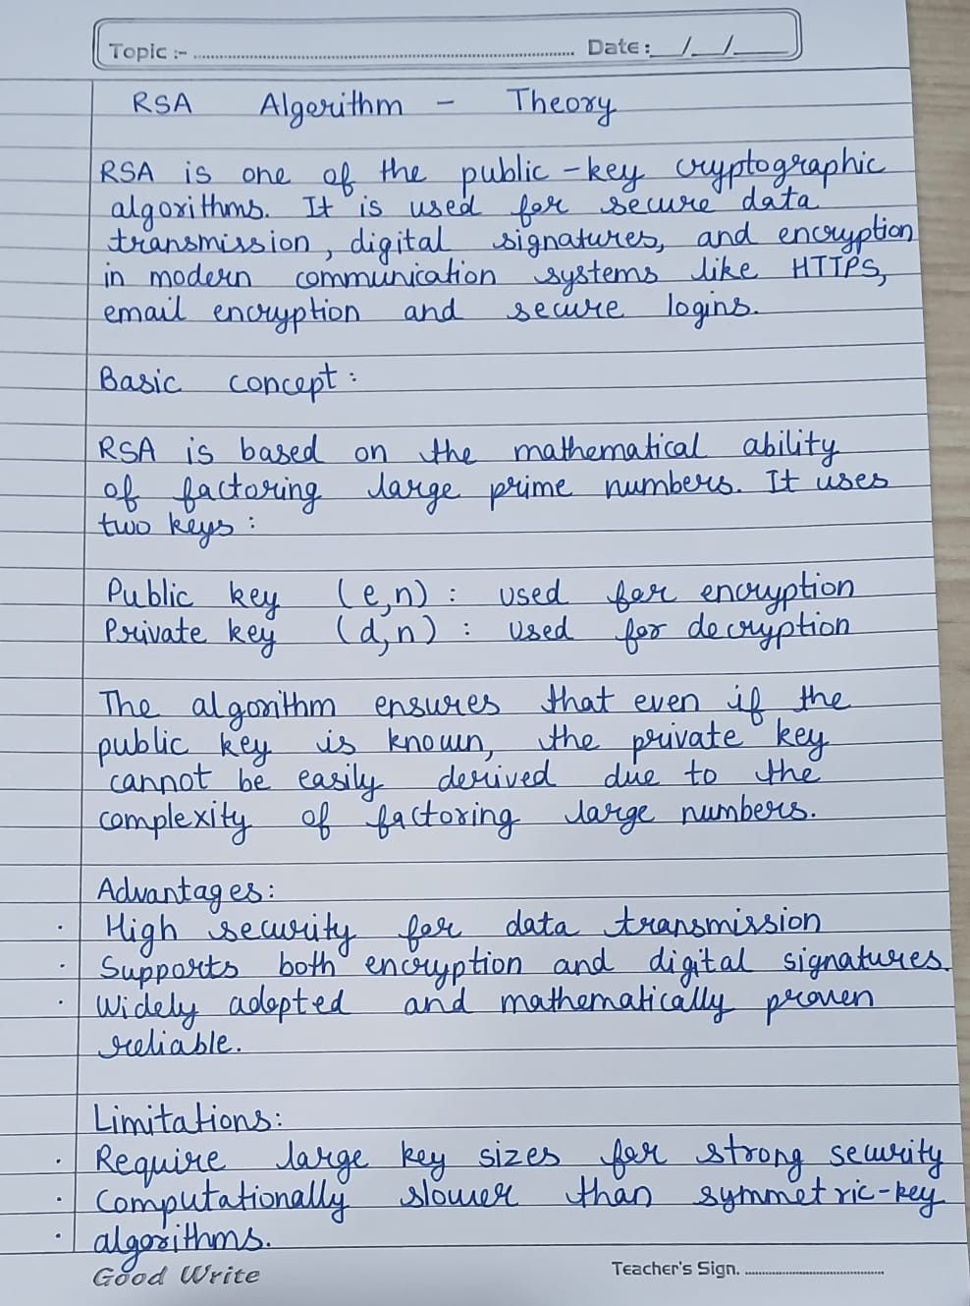

**Numerical Problem**

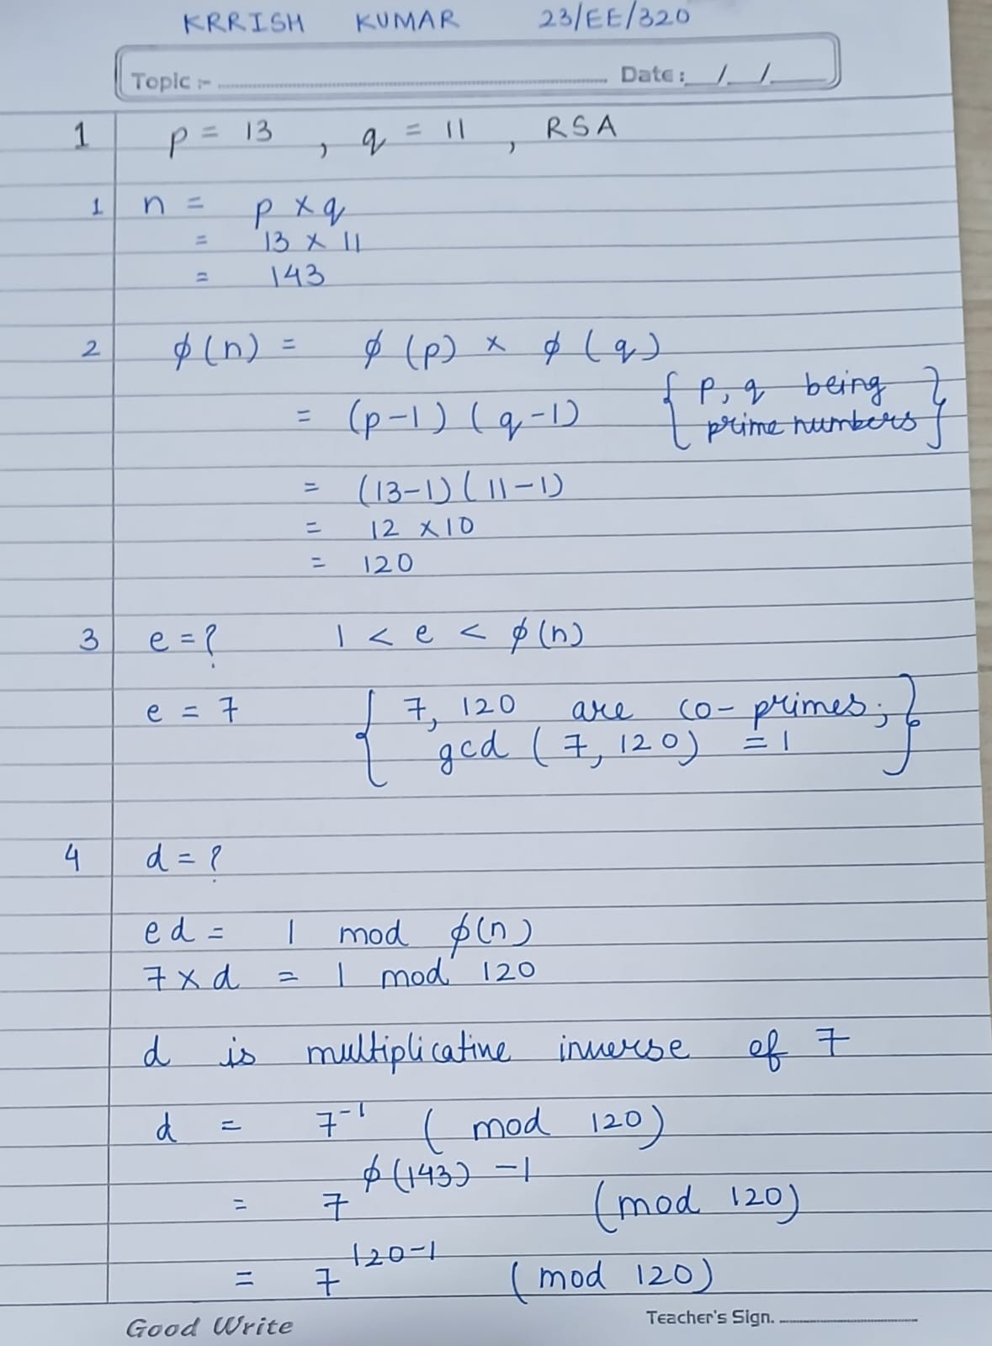

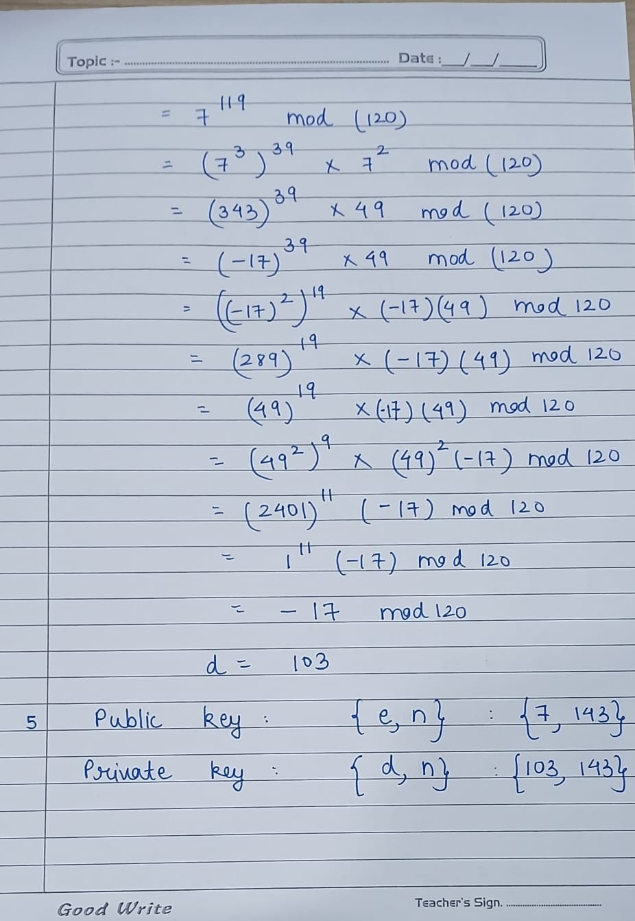

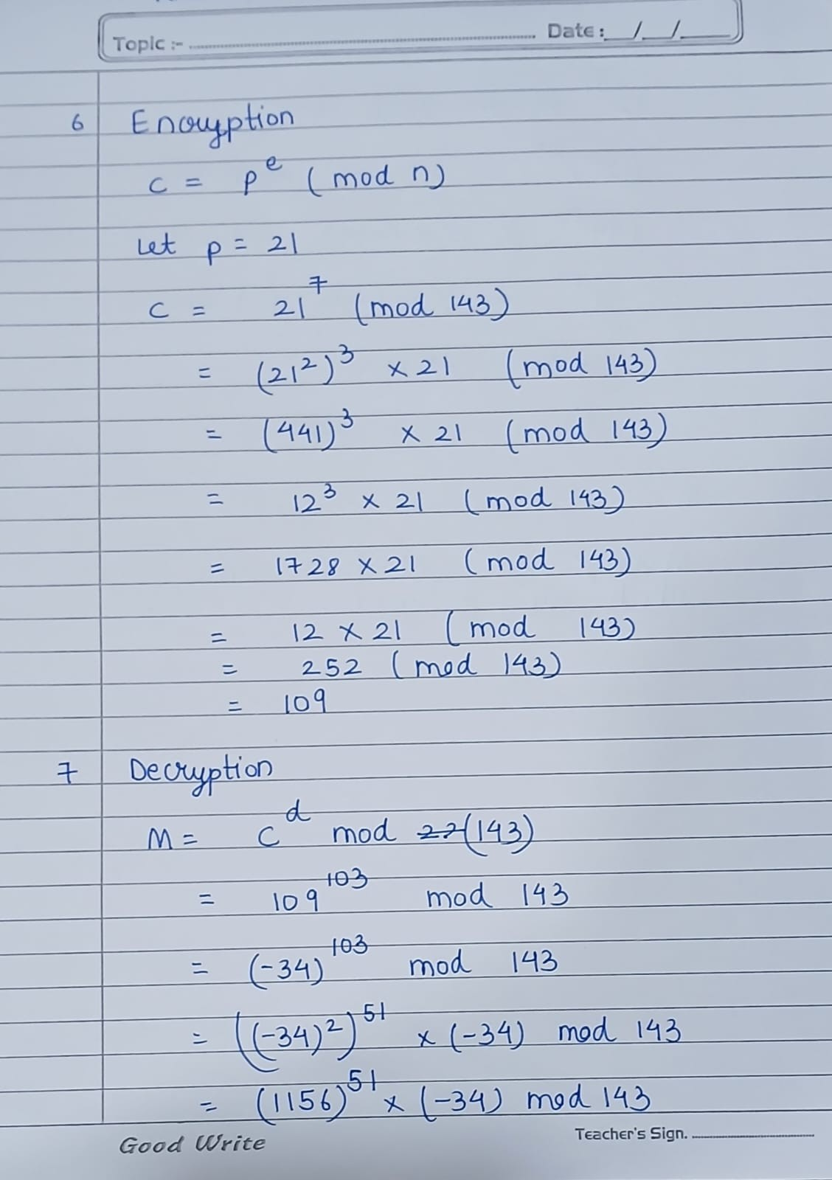

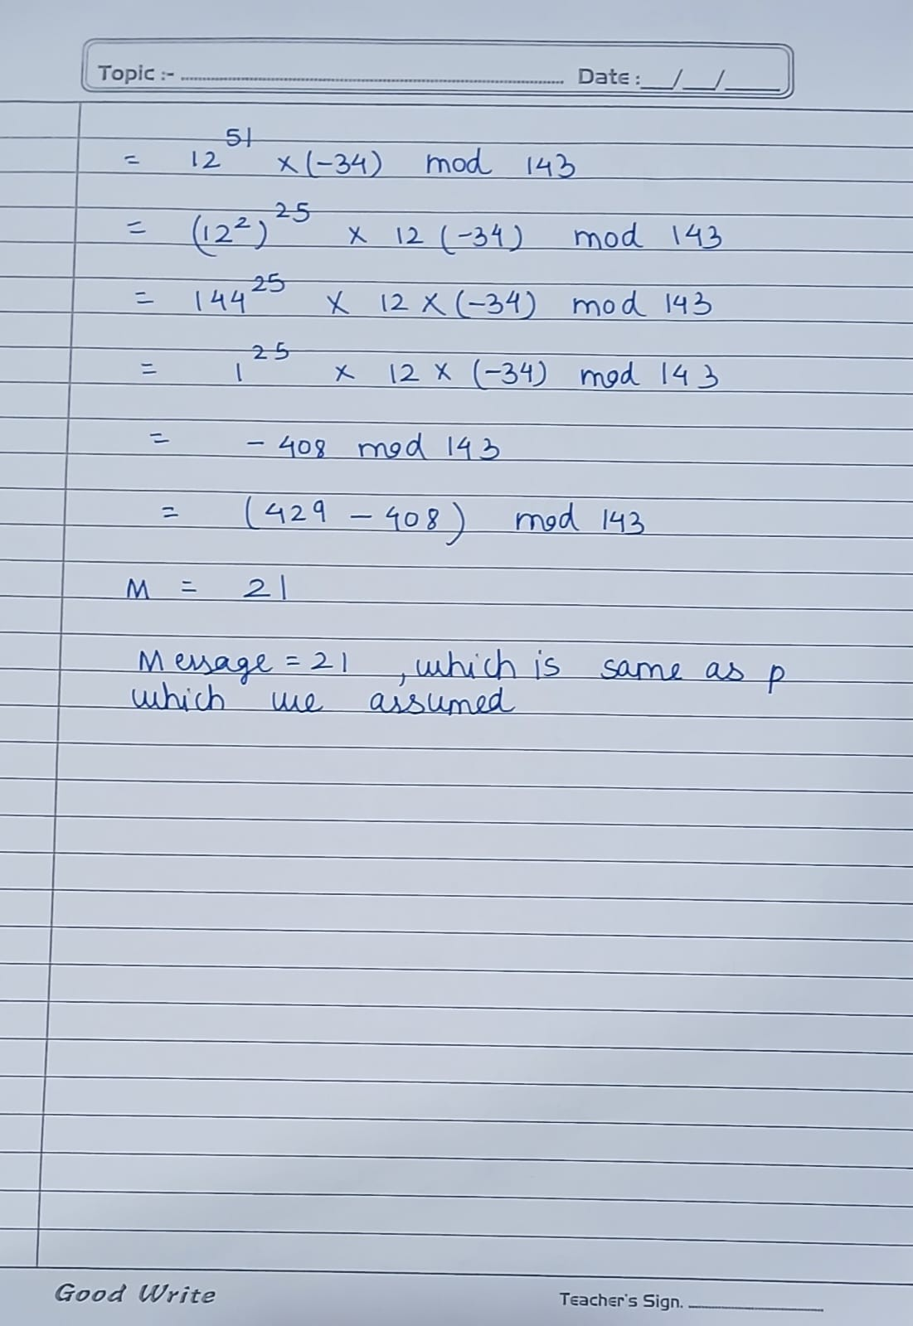

**Code**

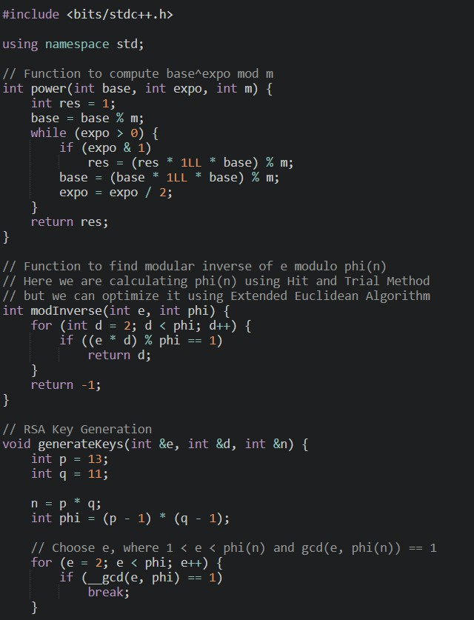

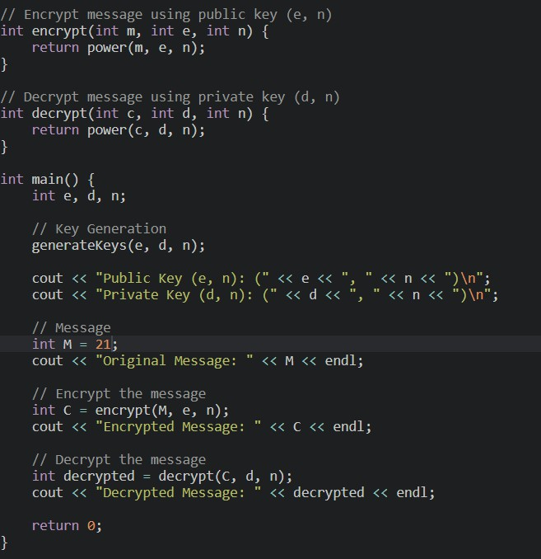

**Output**

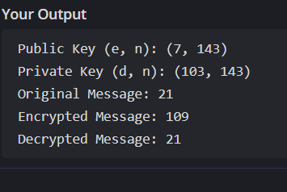

**Learning Outcome**

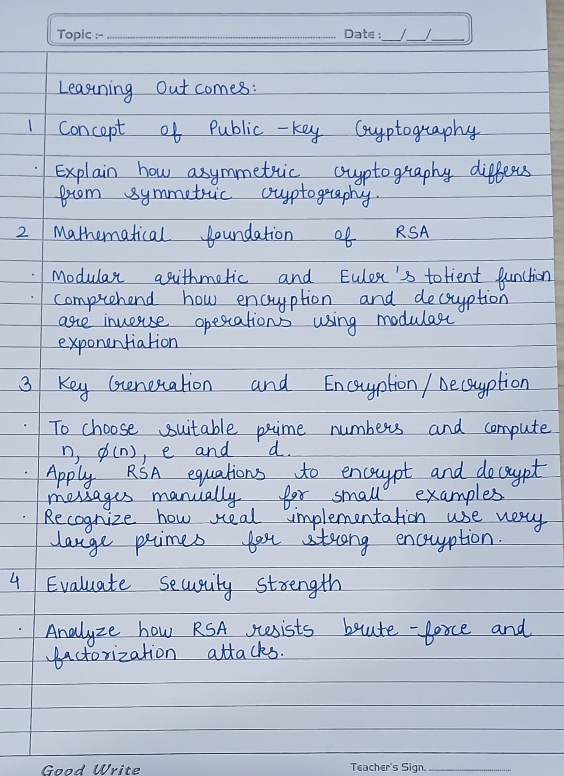

# EXPERIMENT NO. – 5

**Aim** Write a Program to demonstrate how two parties can establish a shared secret key over an insecure communication channel using **Diﬃe-Hellman key exchange algorithm.**

**Theory**

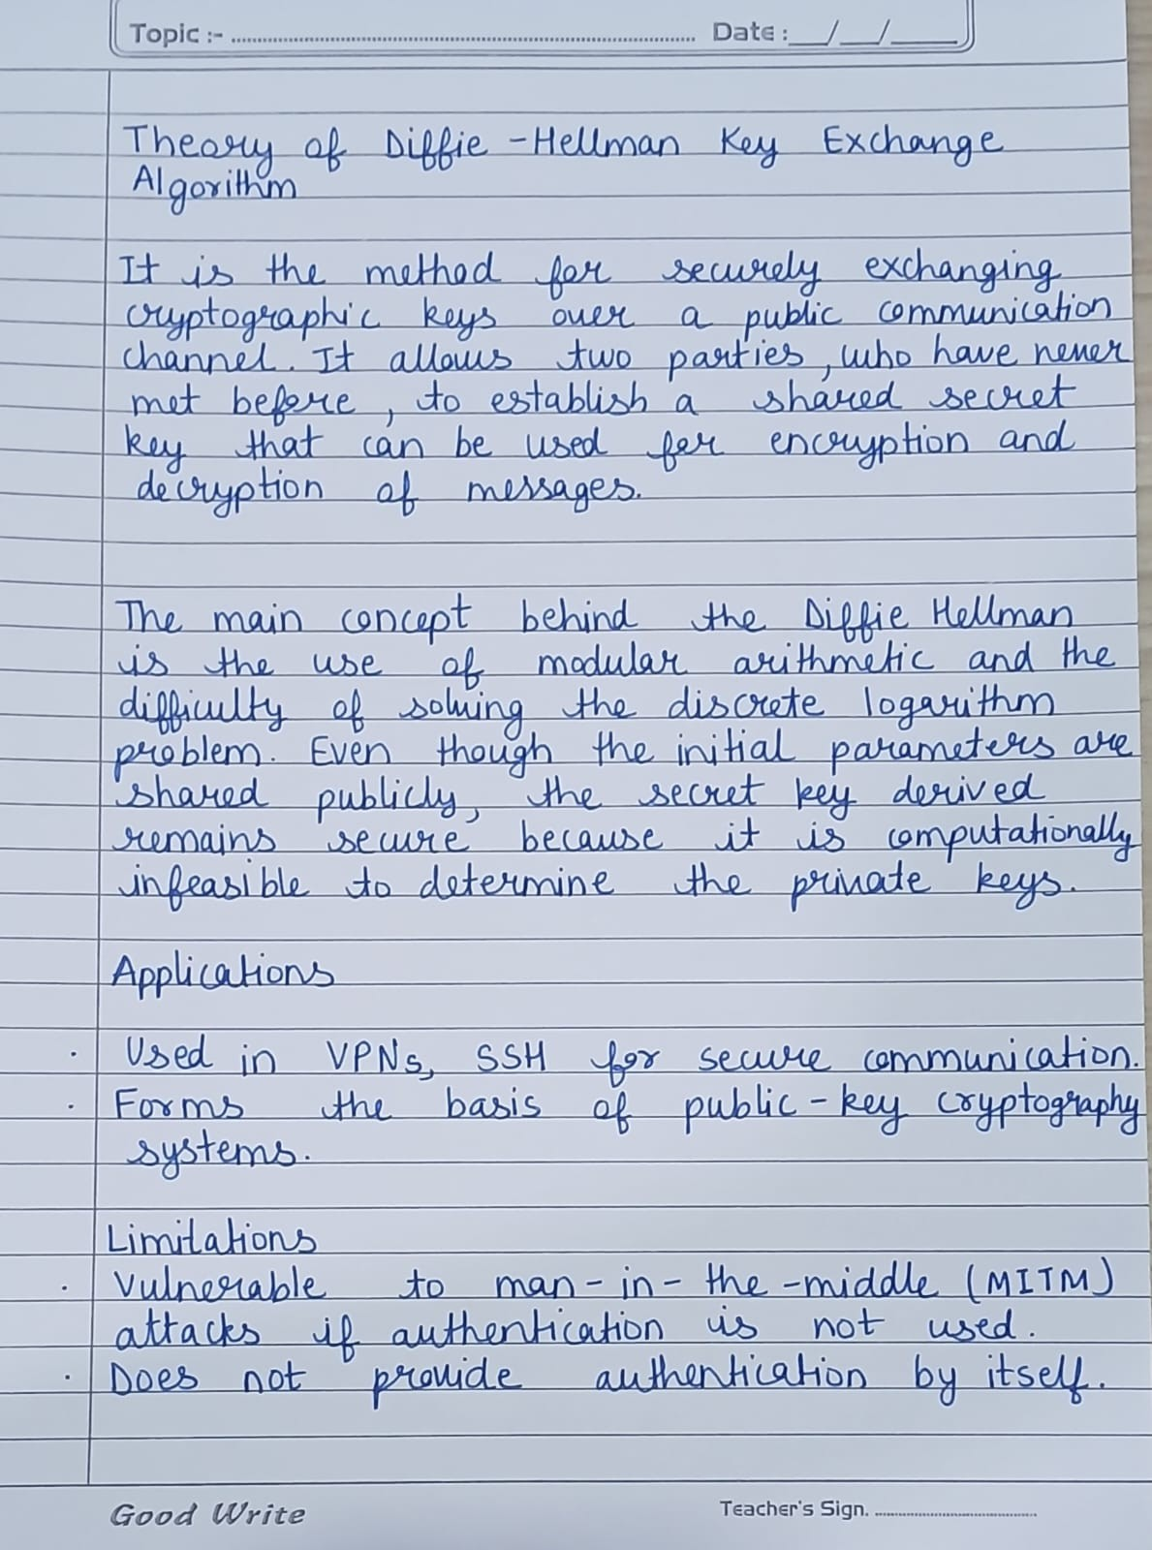

**Numerical Problem**

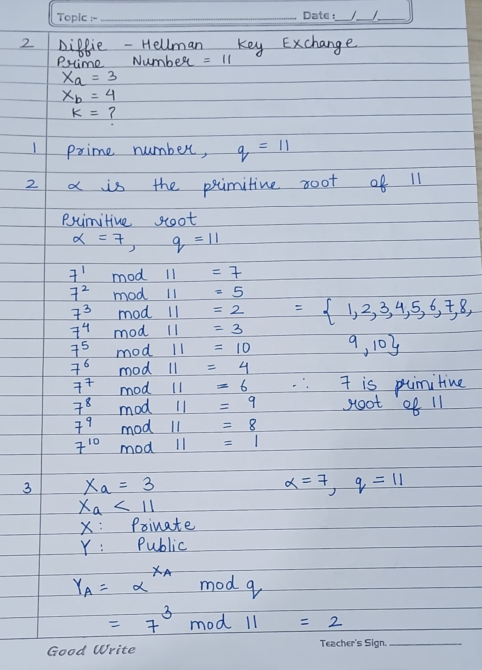

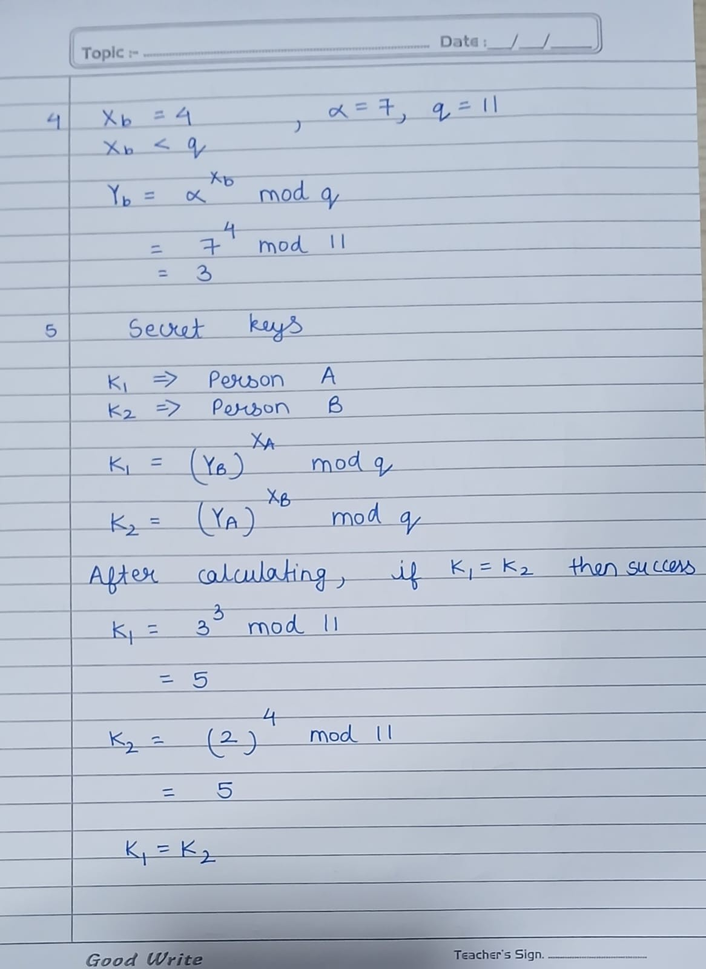

**Code**

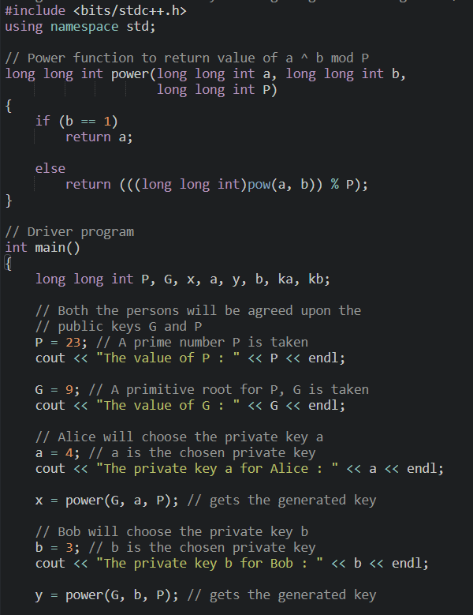

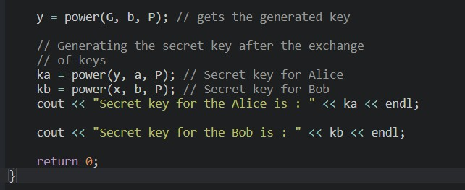

**Output**

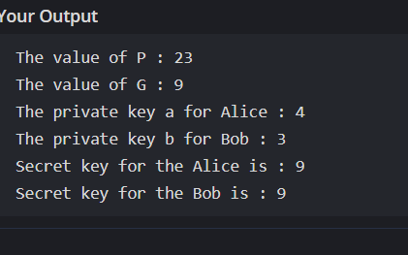

**Learning Outcome**

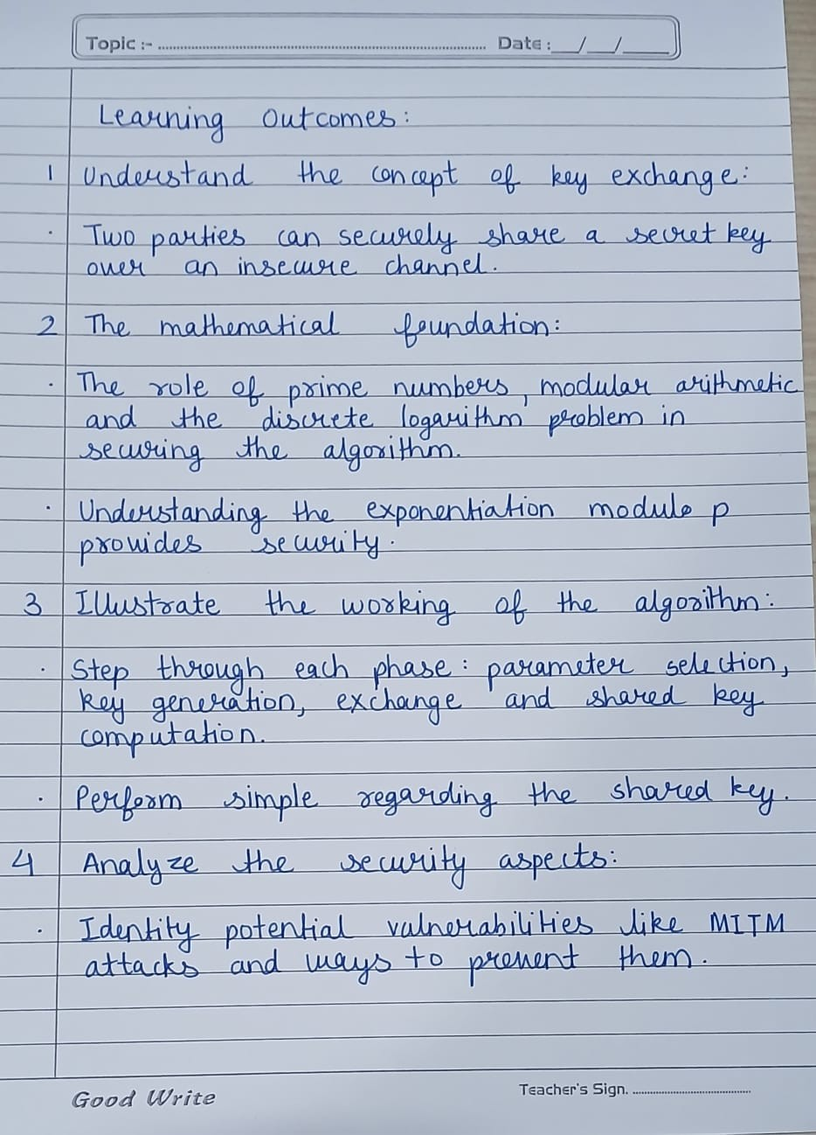

**EXPERIMENT NO. – 6**

**Aim** Write a program to implement the multiplicative inverse of a number under mod.

**Theory:**

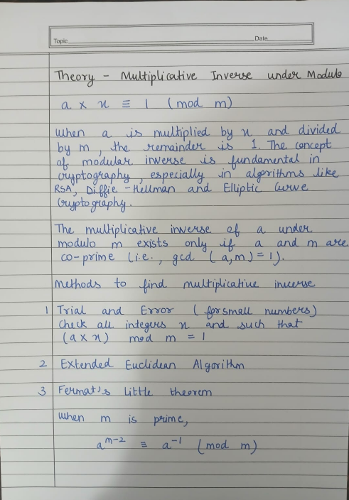

**Numerical Problem**

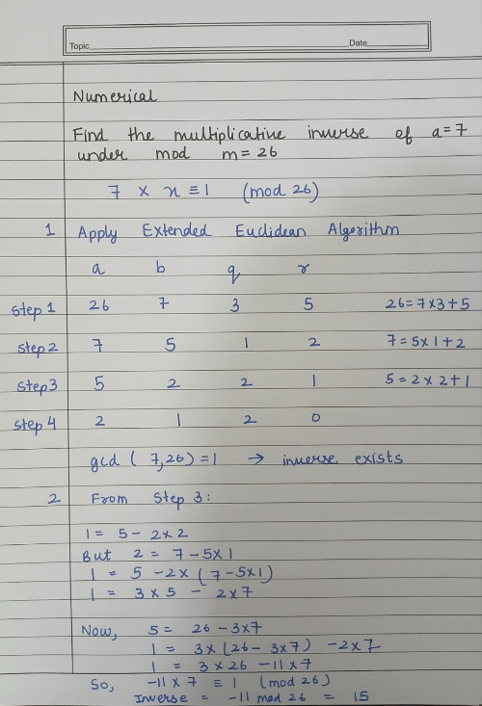

**Code**

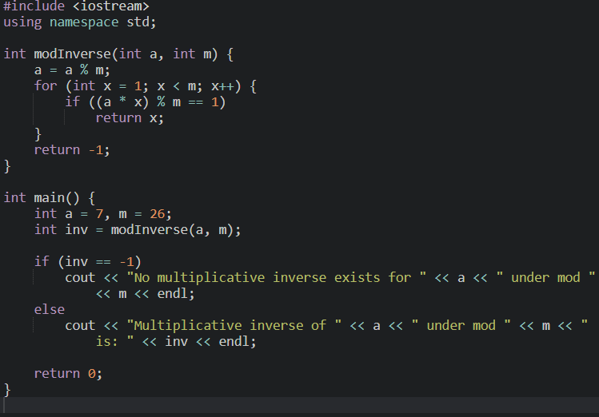

**Output**

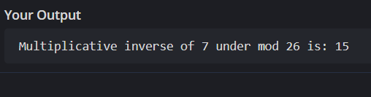

**Learning Outcome**

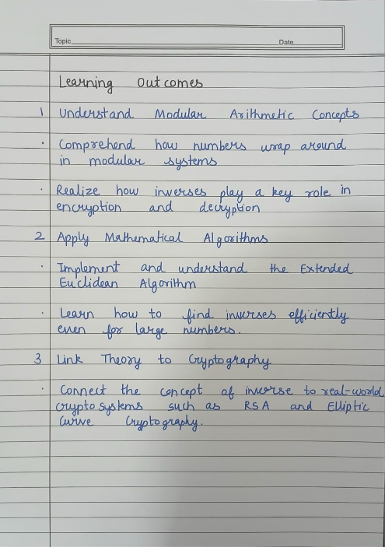

**EXPERIMENT NO. – 7**

**Aim** Write a program that demonstrates the critical properties of the SHA-512 hash function.

**Theory**

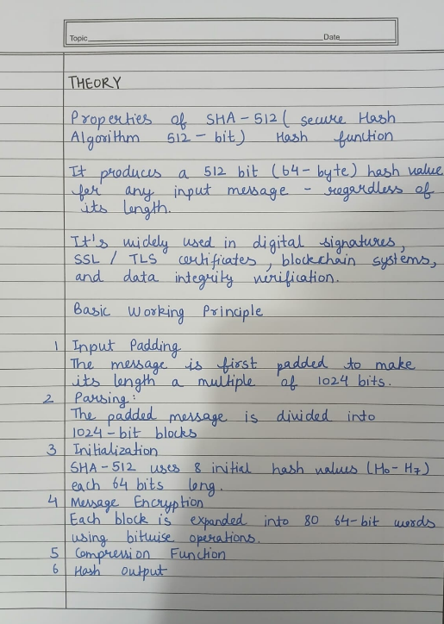

**Code**

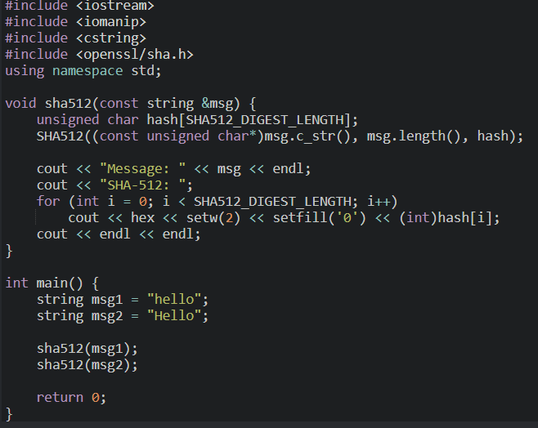

**Learning Outcome**

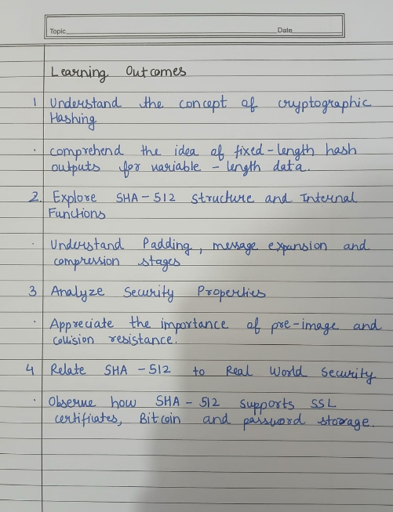

**EXPERIMENT NO. – 8**

**Aim** Write a program to Implementation of Digital Signature Standard (DSS) using RSA based digital signature scheme.

**Theory**

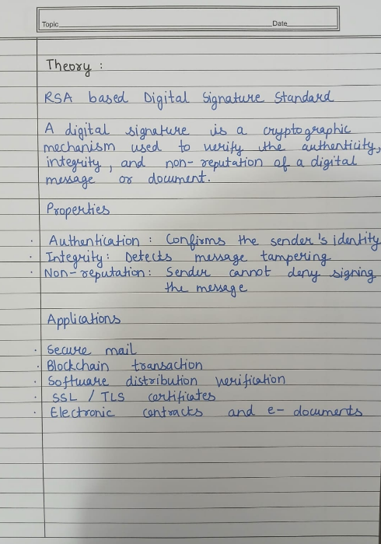

**Numerical Problem**

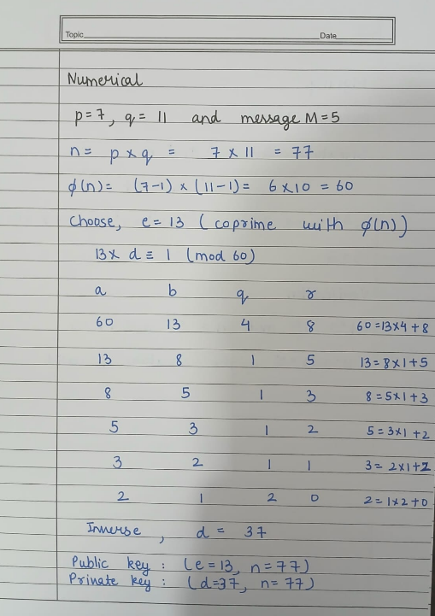

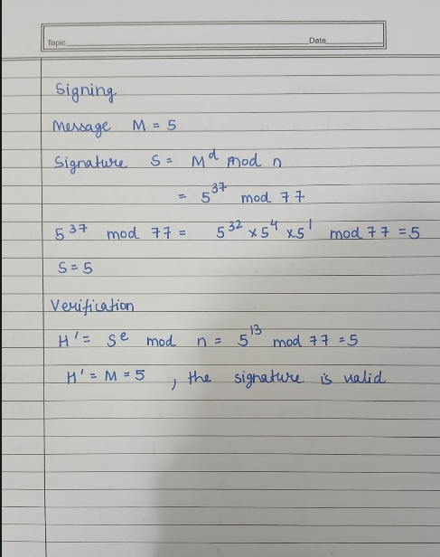

**Code**

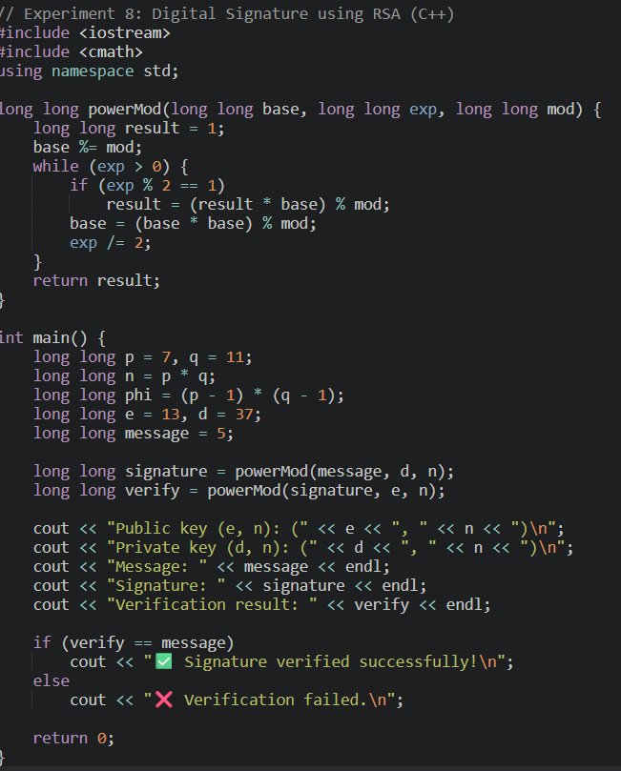

**Output**

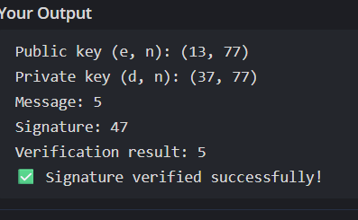

**Learning Outcome**

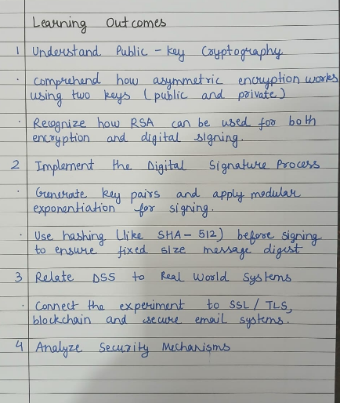

**EXPERIMENT NO. – 9**

**Aim** Installation and usage of Wireshark or tcpdump to capture and analyze network traffic (UDP/TCP/HTTP sessions).

**Theory**

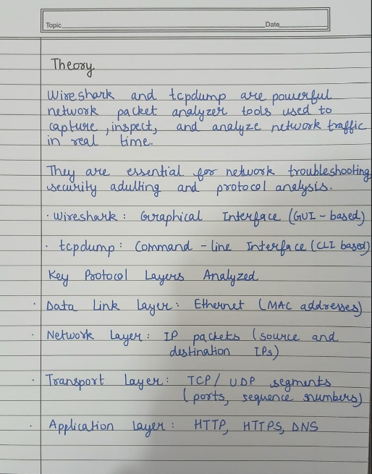

**Code**

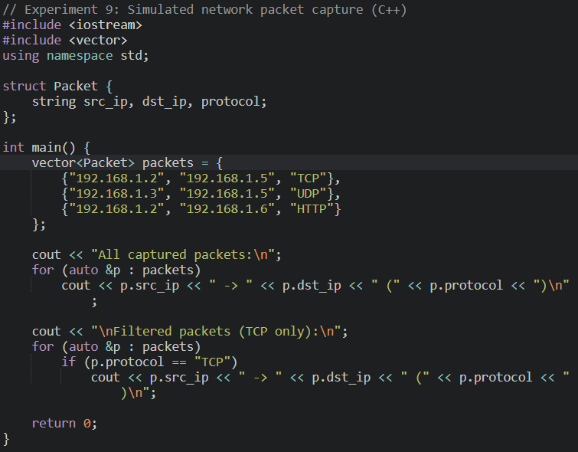

**Output**

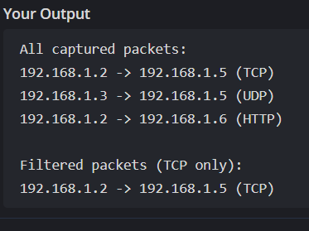

**Learning Outcome**

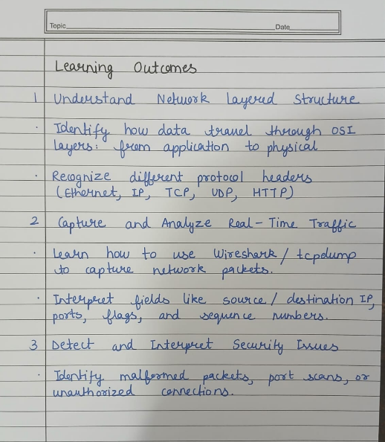

**EXPERIMENT NO. – 10**

**Aim** Experimenting with OpenSSL to set up a secure web server-browser communication channel (SSL/TLS).

**Theory**

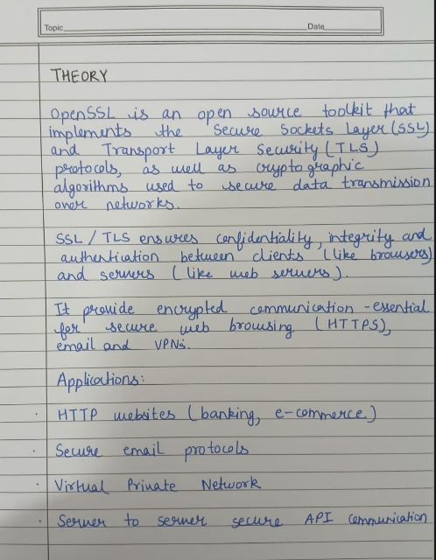

**Code**

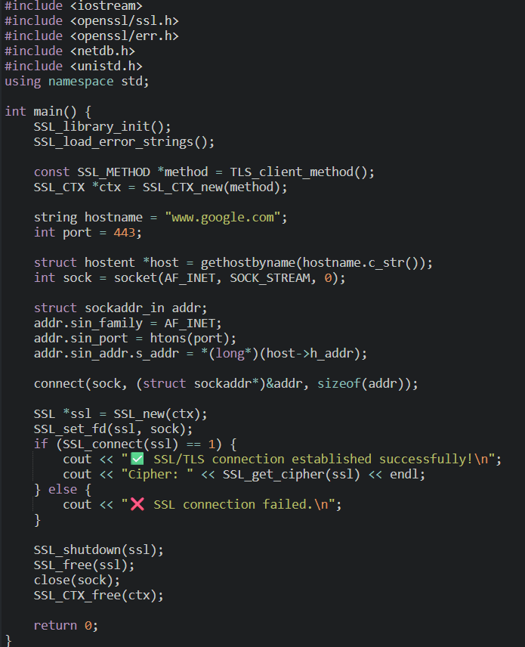

**Output**

**Learning Outcome**

